

UNIVERSITI MALAYSIA TERENGGANU

FACULTY OF OCEAN ENGINEERING TECHNOLOGY & INFORMATICS

SEMESTER 2 2022/2023

FRONT-END PROGRAMMING

CSM 3103

LAB 3 REPORT

PREPARED FOR:

DR. RABIEI BIN MAMAT

PREPARED BY:

MOHAMAD HAZIM BIN MOHD SHAKRI (S61770)

**Lab 3**

**Task 1 – JavaScript Function**

1. **Write a function to find the square of a given number**

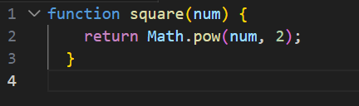

1. **Write a function to find sum of cubes of two numbers**

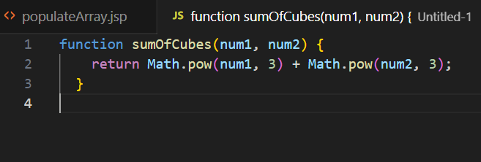

1. **Write a function to reverse a number [ Hint n =12345 output : 54321 ]**

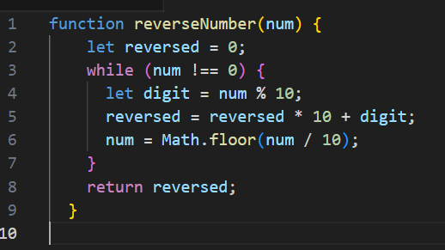

1. **Write a function to print all numbers between 1 and 100 which is divisible by given number z**

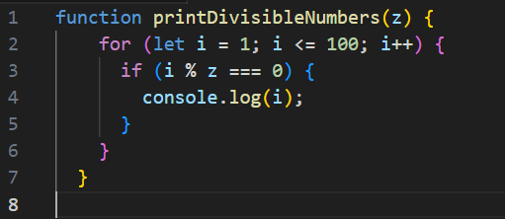

**Task 2 - JavaScript Recursion Function**

1. **Write a JavaScript function to find sum of digits of a number**

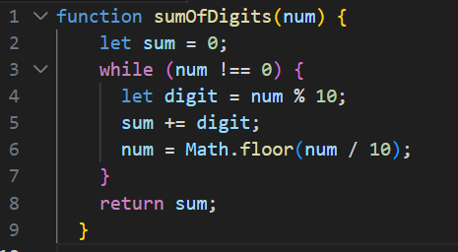

1. **Write a JavaScript program to compute x raise to the power y using recursion**

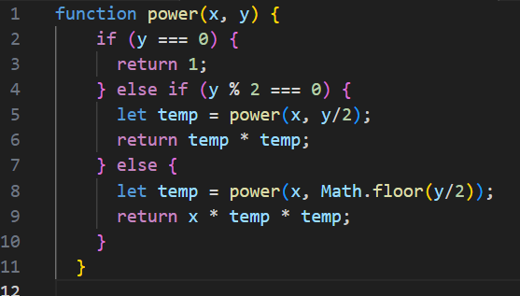

**Task 3 – JavaScript Object and Prototype**

1. **Write a JavaScript program to create object product,**
   1. **Add the property Product Name, Quantity and price.**

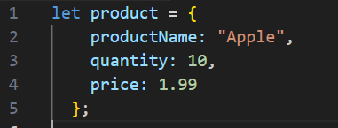

* 1. **Access all the properties and display them.**

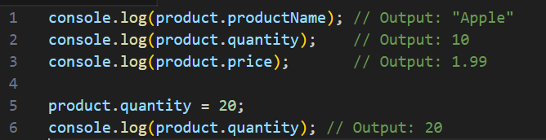

1. **Write a JavaScript program to create object book**
   1. Add the property book name, author name

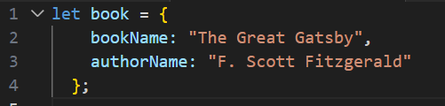

* 1. **Add the prototype property price.**

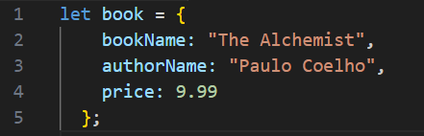

* 1. **Display all the properties**.

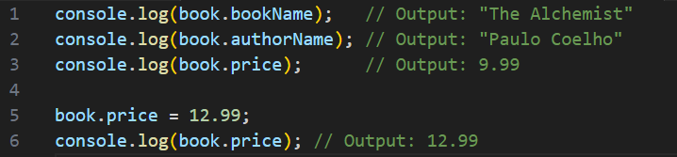

1. **Write a JavaScript program to create Parent object employee (Property : Employee Name , Employee Id , Salary) and Child object Manager (Property : Manager Name , Branch). Inherit all the properties of employee and display all the properties**.

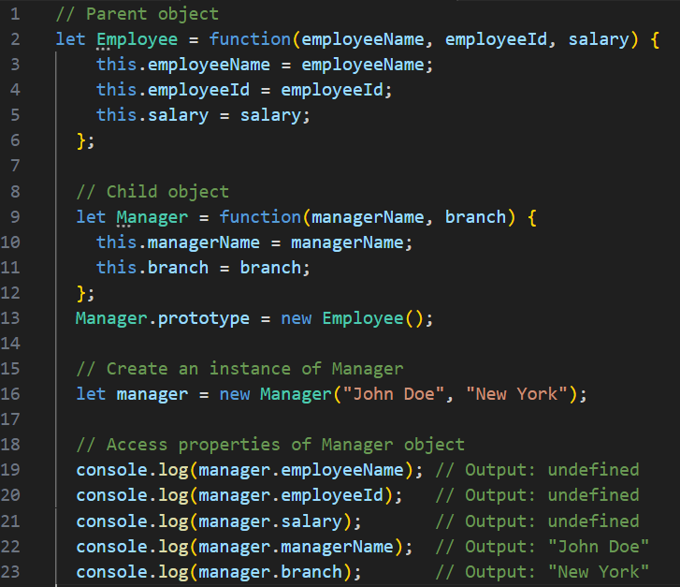

**Task 4 – Event Manager**

1. **Create a HTML page with <p> paragraph. Change the paragraph color according to the following mouse events**
   1. **Onclick, yellow background**

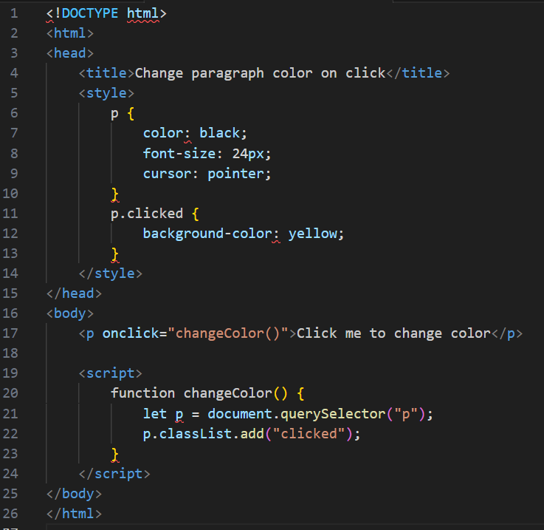

* 1. **ondblclick, blue background**

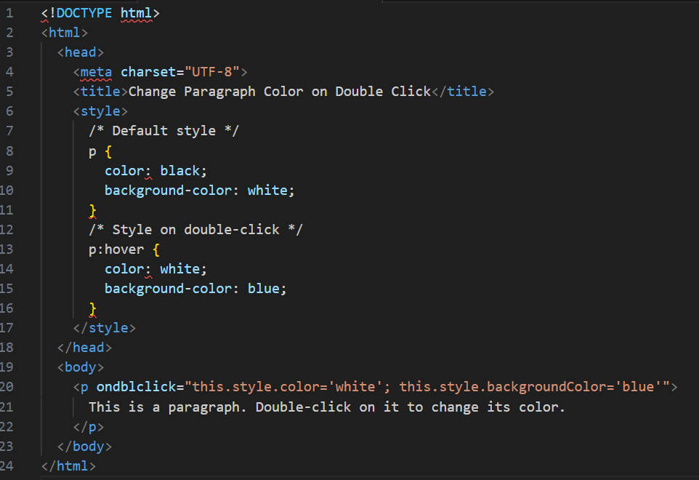

* 1. **onmouseover , red background**

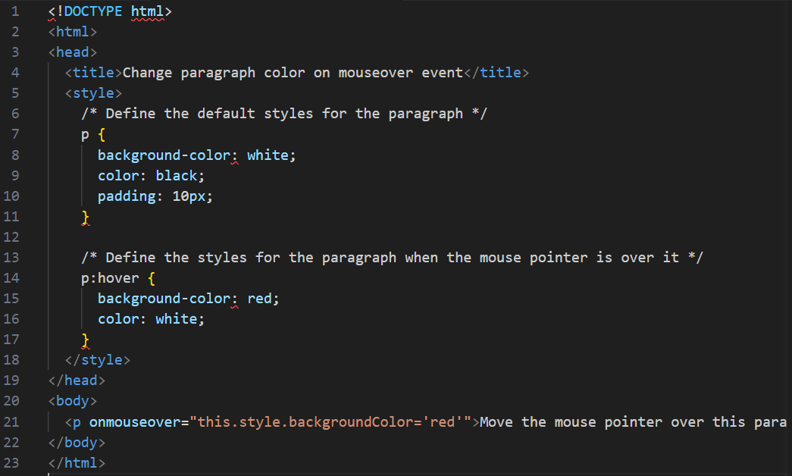

* 1. **onmouseout, green background**

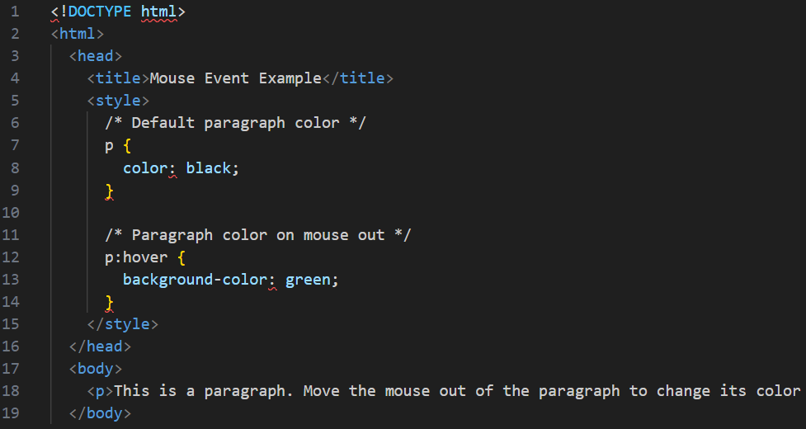

**2. Create a HTML page with textfield. Show some effects on the textfield when the following events occurred:**

* 1. **Onchange**

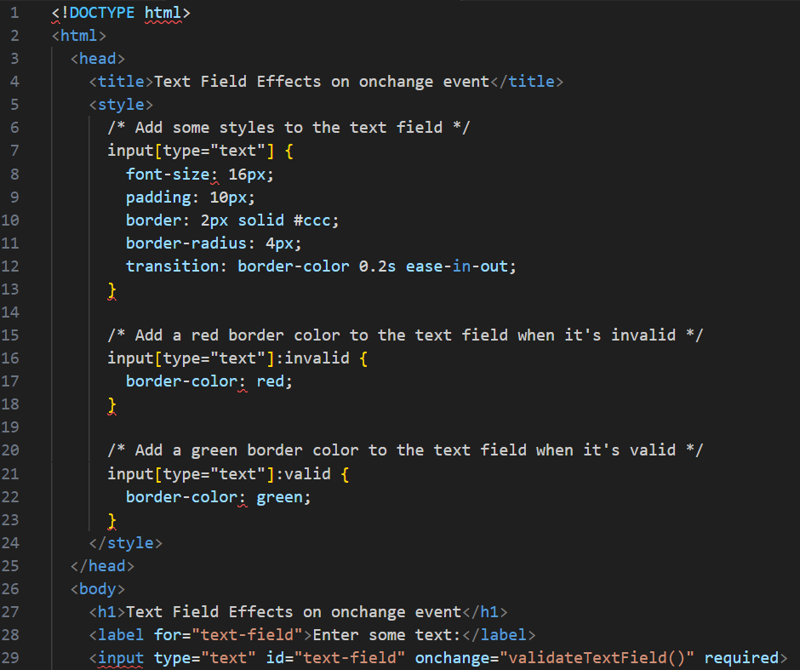

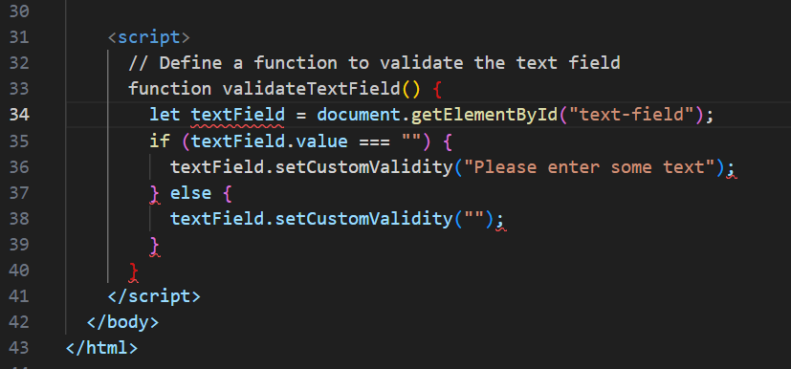

* 1. **Onfocus**

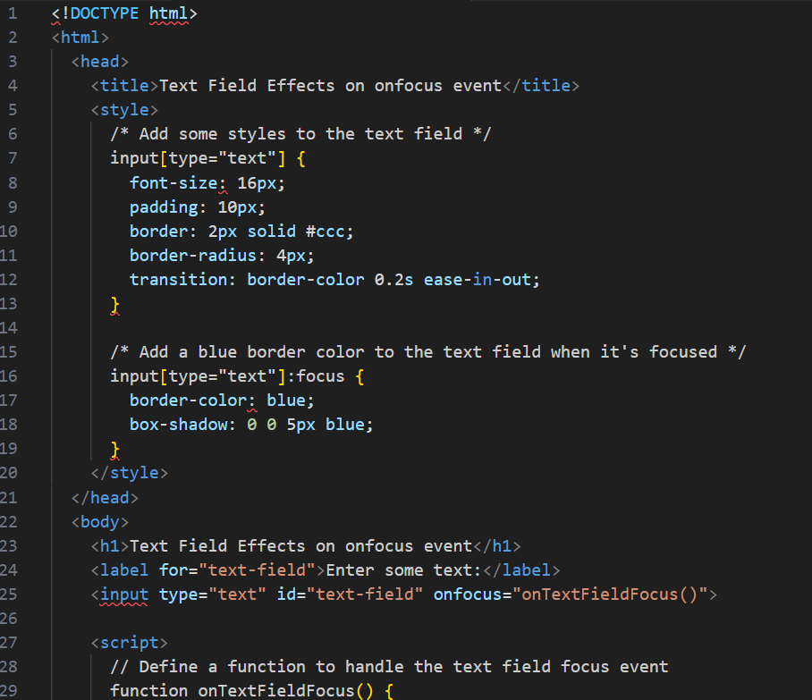

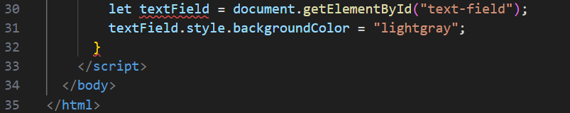

* 1. **Onblur**

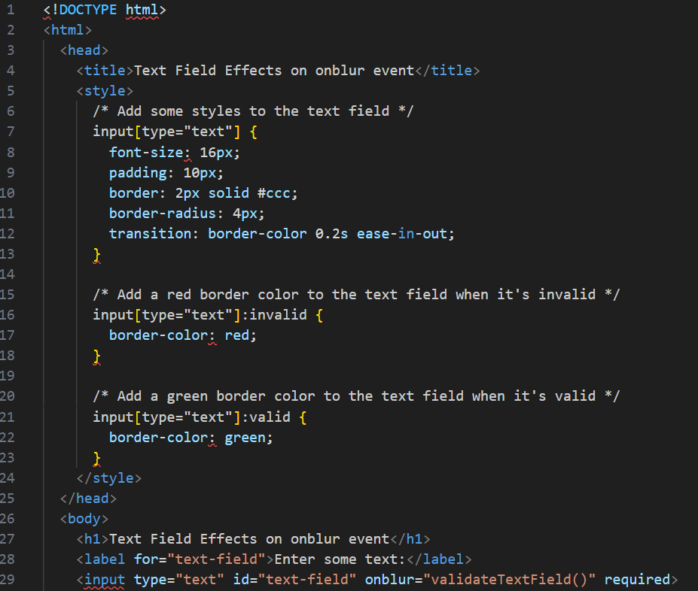

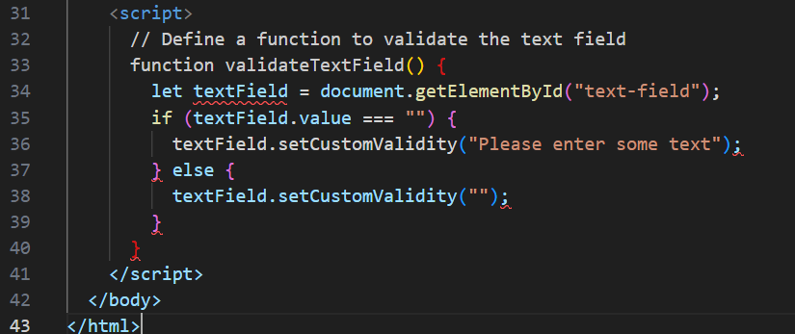

**Task 5**

**Given the following HTML table**

|  |  |  |  |
| --- | --- | --- | --- |
| **1** | **Ahmad Faisal** | [**ahmadfaisal@gmail.com**](mailto:ahmadfaisal@gmail.com) | **0199088888** |
| **2.** | **Ismail Sabri** | [**isabri@mail.com**](mailto:isabri@mail.com) | **0199076760** |
| **3** | **Fateh Yakin** | [**ffateh@hotmail.com**](mailto:ffateh@hotmail.com) | **0176067762** |

1. **Using javascript add the following record into table**
   1. **Name: Mukhriz Jamil Asoka**
   2. **Email:** [**mukriz@corp.jo**](mailto:mukriz@corp.jo)
   3. **Phone: 651181187223**

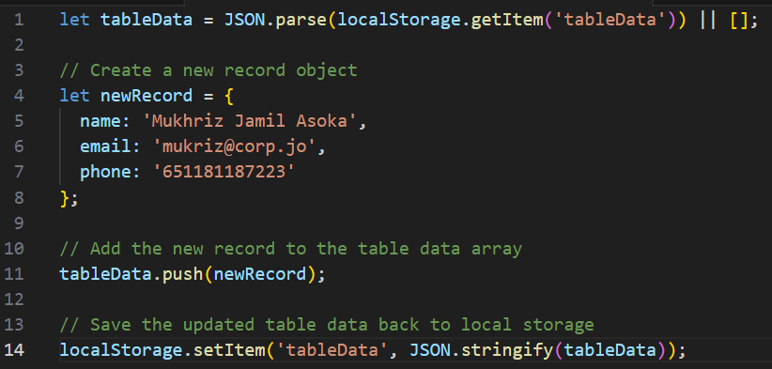

1. **Using javascript add the table header as follow:**
   1. **#, Name, Email, Phone #**

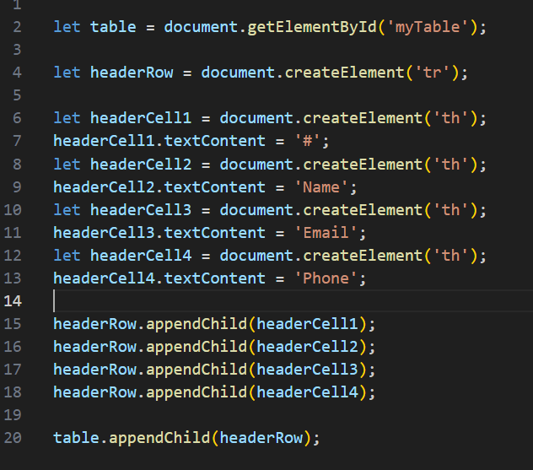

1. **Using javascript, delete any row from table when clicked on that row**

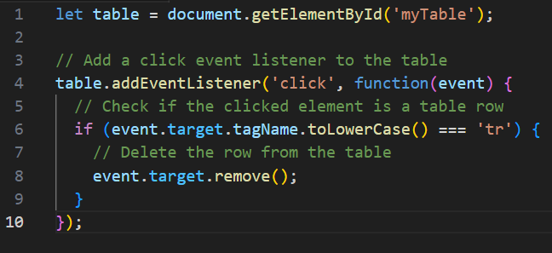

**Task 6**

**Write a JavaScript program to move two small squares inside one big square in a random manner. User should be able to start and stop this animationusing button based events**

**Math.floor(Math.random() * Math.floor(max)) will give you a random number that is less than max value**

